**COGNIZANT**

**Week- Hands on**

**Assignments**

**Microservices with Spring Boot 3 and Spring Cloud**

**Name:*Suriyakumar J***

**Super Set ID:*6387366***

**E-mail:** [suriyakrizz123@gmail.com](mailto:suriyakrizz123@gmail.com)

**Question-1(Creating microservices for account and loan)**

**AccountController.java**

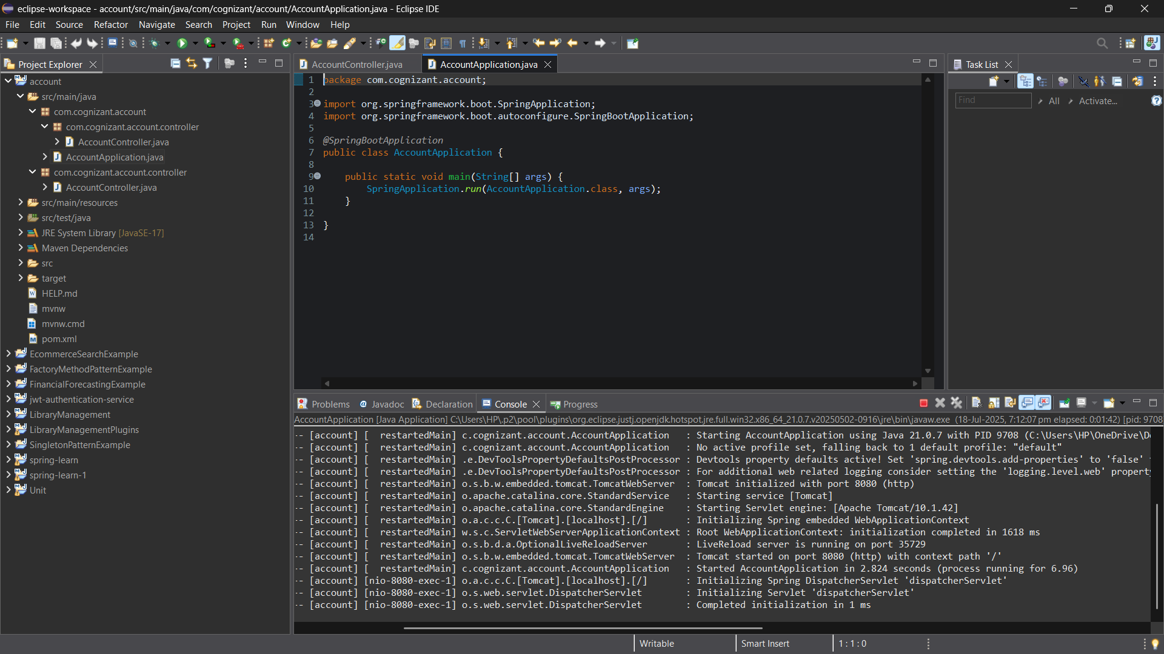

**Output**

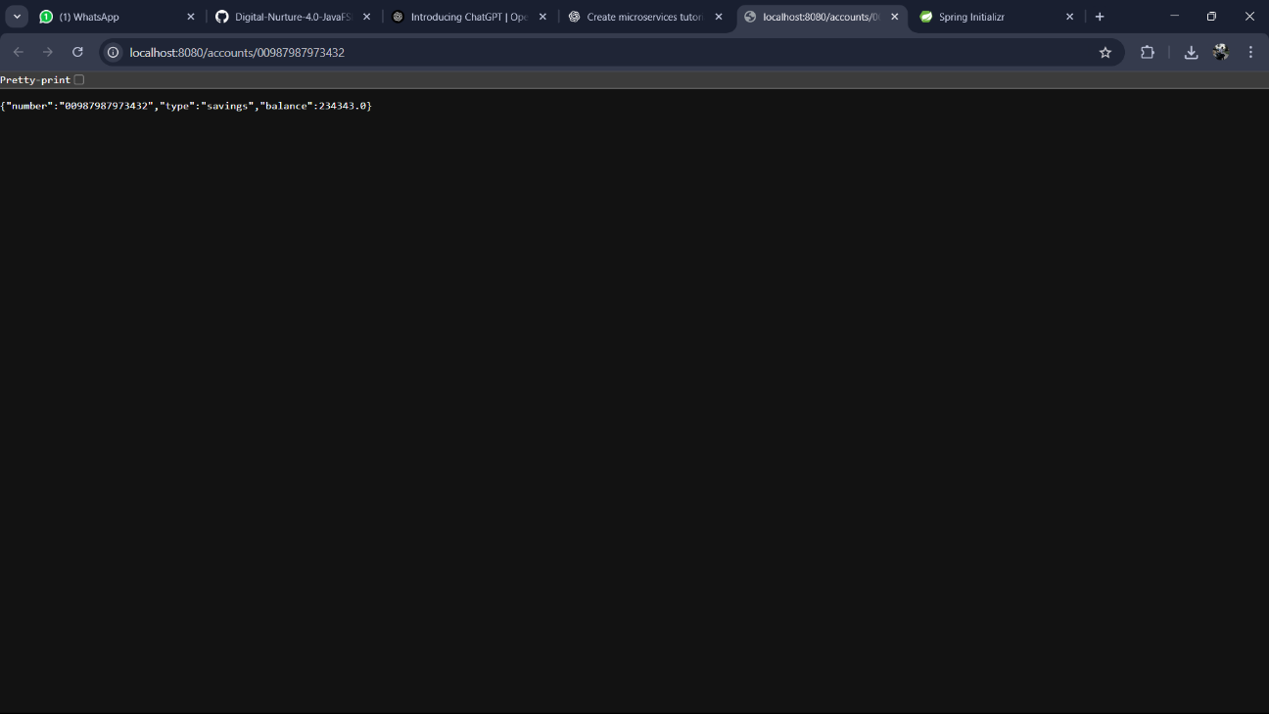

**LoanController.java**

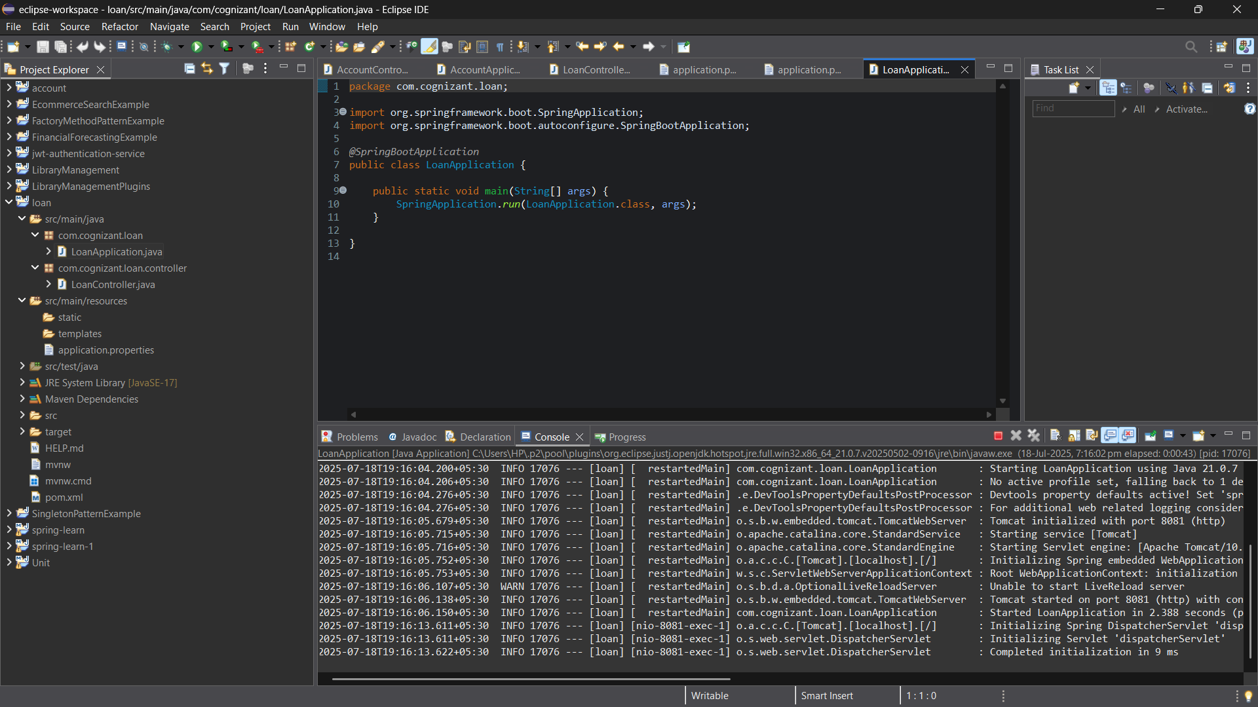

**Output**

